cxeli kerZi
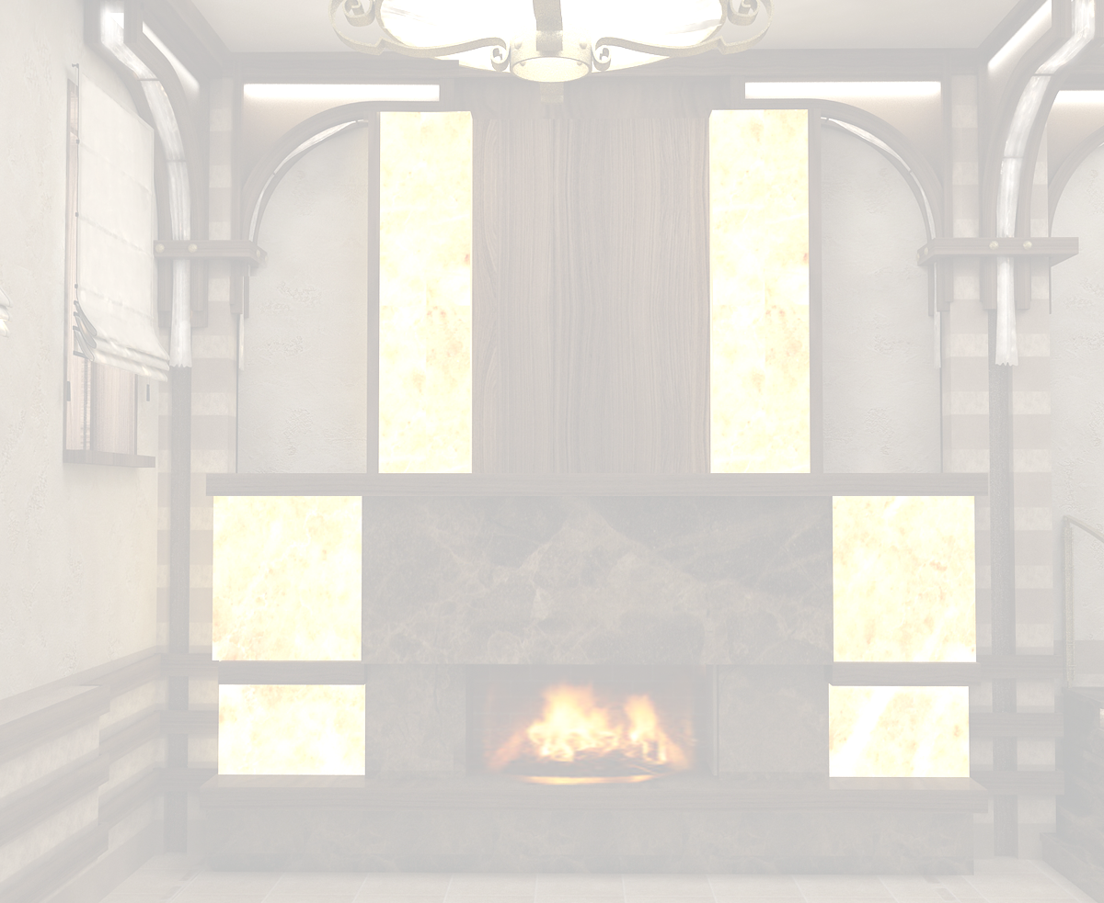Hot Apitaizer
xbos CaSuSuli  SENATE |  |  |  |  | 9.00 | lari
Veal "Chashushuli" On Ketsy Meat stewed with tomatoes, capsicum, onion, greens, spices |  |  |  |  | 9.00 | GEL
xaSlama saqonlis xorcis |  |  |  |  | 30.00 | lari
"Khashkama" Boiled Beef Meat |  |  |  |  | 30.00 | GEL
saqonlis xorcis ostri |  |  |  |  | 15.00 | lari
Beef "Ostri" Casserole With Green And Butter |  |  |  |  | 15.00 | GEL
xbos neknebi ajikiT kecze |  |  |  |  | 15.00 | lari
Chili Beef Ribs On Ketsy |  |  |  |  | 15.00 | GEL
qama sokos CaSuSuli |  |  |  |  | 9.00 | lari
Field-mushroom Stewed With Green |  |  |  |  | 9.00 | GEL
qama soko kecze |  |  |  |  | 9.00 | lari
Field mushrooms on frying-pan |  |  |  |  | 9.00 | GEL
qama soko kecze sulguniT |  |  |  |  | 10.00 | lari
Caps of Field mushrooms with "sulguni" cheese on frying-pan |  |  |  |  | 10.00 | GEL
sokos Julieni |  |  |  |  | 6.50 | lari
"Julienne" Field Mushroom In Sour cream sauce |  |  |  |  | 6.50 | GEL
bivstroganovi |  |  |  |  | 14.00 | lari
"Beefstroganovi" |  |  |  |  | 14.00 | GEL
"madam bovari" |  |  |  |  | 16.00 | lari
"Madam bovari" |  |  |  |  | 16.00 | GEL
Roris xorcis ojaxuri kecze |  |  |  | 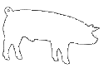 | 9.50 | lari
Pork "Ojaxuri" Pork Ribs With Potato On Ketsy |  |  |  |  | 9.50 | GEL
Roris kareika kartofilis garniriT |  |  |  |  | 12.00 | lari
"Kareika" Pork Ribs With Pepper And oil, Garnished With Potato |  |  |  |  | 12.00 | GEL
megruli "kupati" |  |  |  |  | 12.00 | lari
"kupati" Stuffed Pork (small sausages from fat mincemeat fried on hot charcoals) |  |  |  |  | 12.00 | GEL
imeruli kupati |  |  |  |  | 9.00 | lari
"Kupaty" Stuffed Beef And Pork (small sausages from fat mincemeat fried on hot charcoals) |  |  |  |  | 9.00 | GEL
afxazura |  |  |  |  | 14.00 | lari
"Apkhazura" Stuffed Beef And Pork |  |  |  |  | 14.00 | GEL
kalmaxi Semwvari nigvziTa da soios sousiT |  |  |  |  | 8.50 | lari
Trout Fried With Walnut and Soya sauce |  |  |  |  | 8.50 | GEL
"barabulka" Semwvari |  |  |  |  | 7.50 | lari
Red mullet Fried |  |  |  |  | 7.50 | GEL
wiwila Sqmerulad |  |  |  |  | 18.00 | lari
“Shqmeruli” Baby-Chicken Fried on the frying-pan |  |  |  |  | 18.00 | GEL
“tabaka” |  |  |  |  | 16.00 | lari
Chicken "Tabaka" flat fried chicken in garlic sauce |  |  |  |  | 16.00 | GEL
wiwila "megrulad" |  |  |  |  | 16.00 | lari
Spetial Style of Fraid Baby-Chicken |  |  |  |  | 16.00 | GEL
kievuri katleti Sereuli garniriT |  |  |  |  | 10.00 | lari
Chicken "Kiev" crumbed chicken breast filled with herb butter |  |  |  |  | 10.00 | GEL
Sebolili neknebi moxarSuli |  |  |  |  | 10.00 | lari
Boiled Smoked ribs |  |  |  |  | 10.00 | GEL
“tolma” vazis foTolSi |  |  |  |  | 8.00 | lari
"Dolma" Minced beef and pork with rice stuffed in grape leaves |  |  |  |  | 8.00 | GEL
sosisi |  |  |  |  | 7.00 | lari
Sosigege |  |  |  |  | 7.00 | GEL
cxare  spicy | vegeterianuli  vegetarian | alkoholuri  Cortains alcohol | Roris xorci  pork | Till 18:00   18:00 saaTamde
visac dietis an alergiis gamo surs icodes sakvebis Semadgenloba, gTxovT mimarToT mimtans
For those with special dietary requirements or allergies, please ask our waiter for assistance
momsaxureoba-15%
Service charge-15%

